Application form
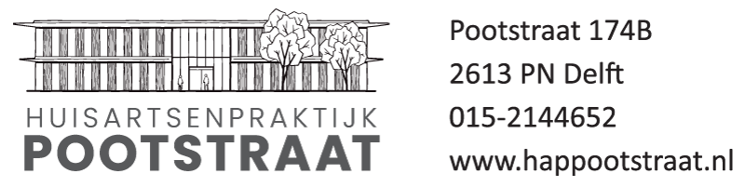
Doctors:
Mw. H. Rick
Mw. M. Ham
Mw. L. de Jong

Thank you for signing up for our GP practice. Note that we only subscribe new patients who live close to our general practice. Only L. de Jong accepts patients.
Please check with our assistants first if your address is included in our service area first before you continue reading. If you already have a Dutch GP in Delft, it is NOT possible to register here.

For registration we need you to fill out three forms:
Application form A: includes general information about you and your relatives.
Application form B: includes questions about your medical history. Please fill out a separate form B for every family member.
Application form C: includes your agreement and signature for online services, sharing medical information with emergency services (spoedpost HAPSchievliet) and pharmacy. You thereby have to agree for sending your medical history from a previous Dutch general practice, if available.
All family members aged over 16 need to sign. Even if you never had a Ducth GP!

Online services: When you’ve been registered, you will receive a digital invitation for our online environment. This gives the opportunity to access our online services including email consultation.
Every family member needs to register with their own e-mail address.

For complete registration you need to come to our office and submit the application form and show us your ID (passport or ‘verblijfstitel’) and insurance card. Only with complete forms we can registrate you.

H. Rick, huisarts
M. Ham, huisarts
L. de Jong huisarts

Application form A

Main insured person
Initials & first name: M/F
Surname:
Date of birth:
DUTCH phone number(s) 06-
Citizen service number (BSN):
Mailadres: @
ID: Passport/ID card/’Verblijfstitel-card’ no:
Address in Delft
Postal code:
Health care provider:
Insurance number:
Preferred pharmacy in Delft (REQUIRED TO CHOSE!):
ION aangemeld (invullen door assistente)
LSP aangemeld (invullen door assistente)

Family members:
In case of divorce, we need to know if parents both have parental authority: Yes/ No

Initials & first name: M/F
Surname:
Date of birth:
DUTCH phone number(s) 06-
Citizen service number (BSN):
Mailadres: @
ID: Passport/ID card/’Verblijfstitel-card’ no:
Health care provider:
Insurance number:

Initials & first name: M/F
Surname:
Date of birth:
DUTCH phone number(s) 06-
Citizen service number (BSN):
Mailadres: @
ID: Passport/ID card/’Verblijfstitel-card’ no:
Health care provider:
Insurance number:

Initials & first name: M/F
Surname:
Date of birth:
DUTCH phone number(s) 06-
Citizen service number (BSN):
Mailadres: @
ID: Passport/ID card/’Verblijfstitel-card’ no:
Health care provider:
Insurance number:

Initials & first name: M/F
Surname:
Date of birth:
DUTCH phone number(s) 06-
Citizen service number (BSN):
Mailadres: @
ID: Passport/ID card/’Verblijfstitel-card’ no:
Health care provider:
Insurance number:
Application form B registration date:

Name:______________________________________Date of birth:________________

Profession or study:

Do you suffer from chronic diseases (high bloodpressure, diabetes, heart problems etc.)

Do you have any major medical history (for example, operations)? If so, please also give dates,

Do you smoke?
Yes/ no/ in the past

Have you received vaccination for influenza in the past?
Yes/ no

Do you use medication? (please give name, dose and dosage)
Name and dose | Dosage

Do you suffer from any allergies?

Hereditary illnesses?

Other important information?

Application form C
(Note that we need this declaration form from every family member aged above 16!)

I, name _______________________________________ date of birth____________________
hereby confirm that I wish to be registered as a new patient of Huisartsenpraktijk Pootstraat, Delft, L. de Jong, GP.
I agree that a copy of this form can be used to request for correction of insurance declarations sent to the insurance company.
I agree to registration for online services using my e-mail address.

I agree to share my medical history with emergency services (huisartsenpost) and
hospital. ( www.ikgeeftoestemming.nl )
- Yes, I agree
- No, I decline

I agree that my medical file will be reclaimed from my previous (Dutch) general practitioner.
The medical file can be sent electronically to Huisartsenpraktijk Pootstraat (AGB 01009033)

Family members aged under 16
Name | Date of birth

Information previous general practitioner in The Netherlands

Name office/doctor:
Phone number:
Address:
City:
MAIL ADDRESS (Please check this for us! Obligate!)
Date: Your signature:

